ArgoCD Tasks
PART 1 — Setup Argo CD
Step 1: Check EKS cluster
First make sure your EKS cluster is working.
aws eks update-kubeconfig \
--region ap-south-2 \
--name venu-cicd-eks
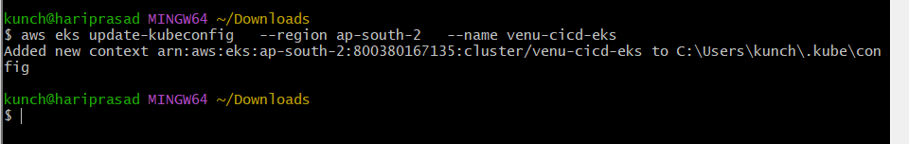Check:
kubectl get nodes
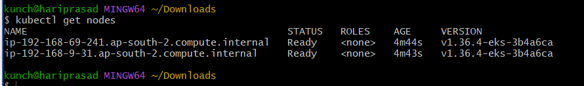
Expected:
NAME STATUS ROLES AGE VERSION
ip-xxx-xxx-xxx-xxx... Ready <none> ... v1.xx.x
Also check:
kubectl cluster-info
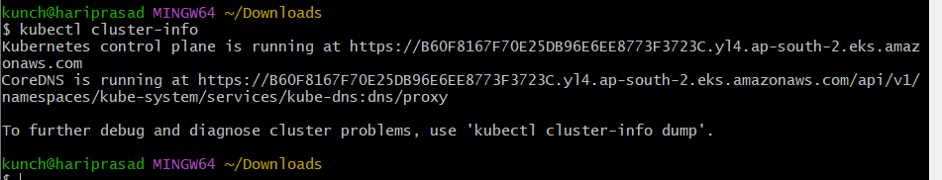

Step 2: Create Argo CD namespace
kubectl create namespace argocd
Check:
kubectl get namespace
You should see:
Argocd
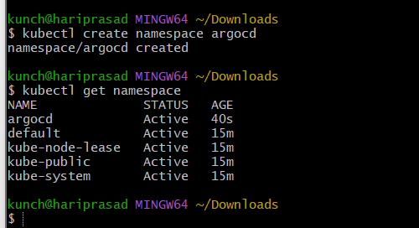

Step 3: Install Argo CD
Run:
kubectl apply -n argocd \
-f https://raw.githubusercontent.com/argoproj/argo-cd/stable/manifests/install.yaml
Wait a few minutes.
Check:
kubectl get pods -n argocd
You should eventually see:
argocd-application-controller Running
argocd-applicationset-controller Running
argocd-dex-server Running
argocd-notifications-controller Running
argocd-redis Running
argocd-repo-server Running
argocd-server Running
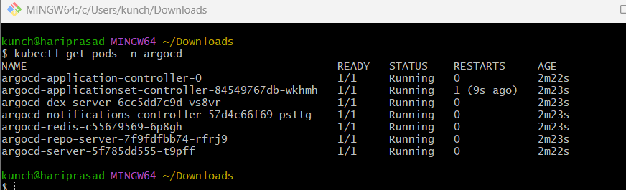

Step 4: Expose Argo CD
For your AWS lab, NodePort is simple.
kubectl patch svc argocd-server \
-n argocd \
-p '{"spec":{"type":"NodePort"}}'
Check:
kubectl get svc -n argocd
Example:
NAME TYPE CLUSTER-IP EXTERNAL-IP PORT(S)
argocd-server NodePort 10.100.x.x <none> 80:xxxxx/TCP,443:xxxxx/TCP
You can access Argo CD through:
https://<EKS-NODE-PUBLIC-IP>:<NODEPORT>
You may need to allow the NodePort in the EC2 security group.
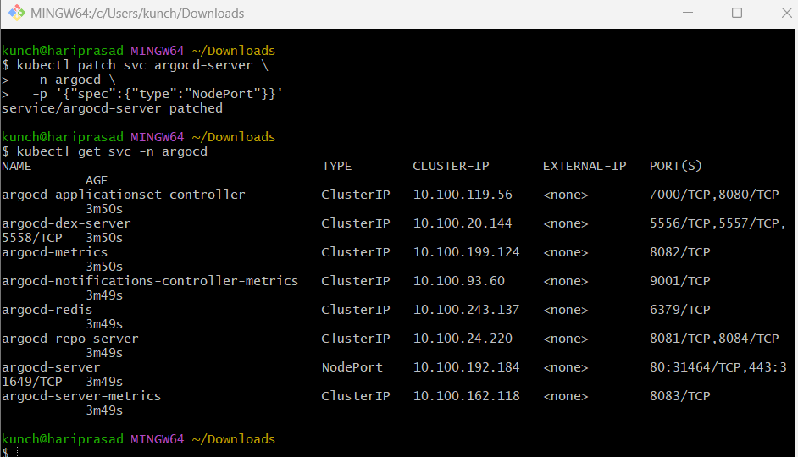

Step 5: Get Argo CD admin password
Run:
kubectl -n argocd get secret argocd-initial-admin-secret \
-o jsonpath="{.data.password}" | base64 -d
Copy the password.
Username:
admin
orj57nBIRlnDlBoI
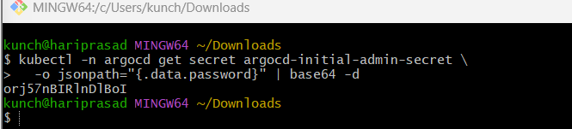

Step 6: Install Argo CD CLI
If you're working from Linux:
curl -sSL -o argocd-linux-amd64 \
https://github.com/argoproj/argo-cd/releases/latest/download/argocd-linux-amd64
Or you can use the Argo CD web UI instead.
Check:
argocd version
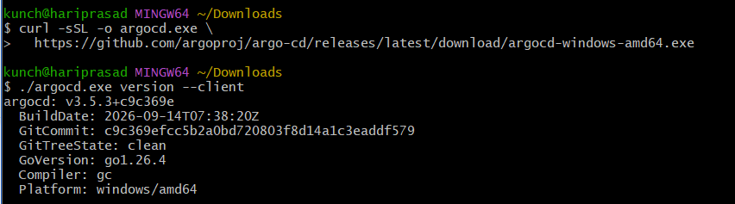
Login:
argocd login <ARGOCD_SERVER>:<PORT> --username admin
For a lab environment with self-signed TLS:
argocd login <ARGOCD_SERVER>:<PORT> \
--username admin \
--insecure
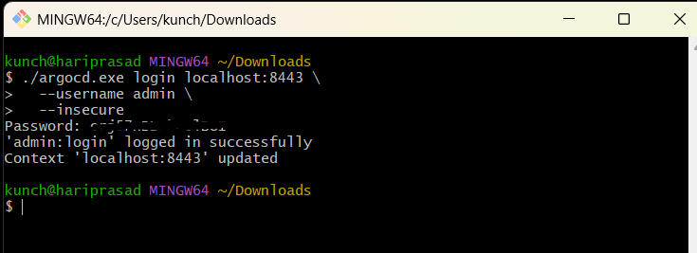
Then open your browser: https://localhost:8443
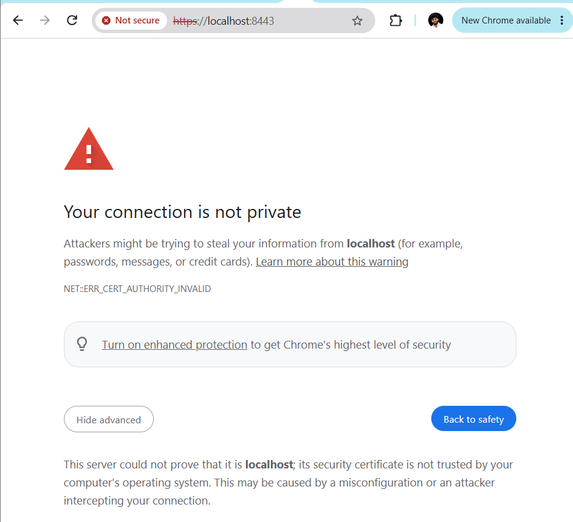
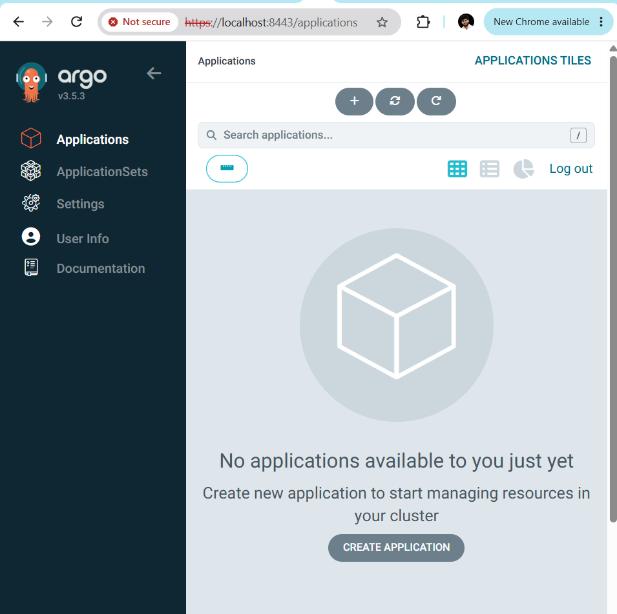

TASK 2 — Create Jenkins Job for CI
Step 1: Create application GitHub repository
Create a GitHub repository:
venu-app
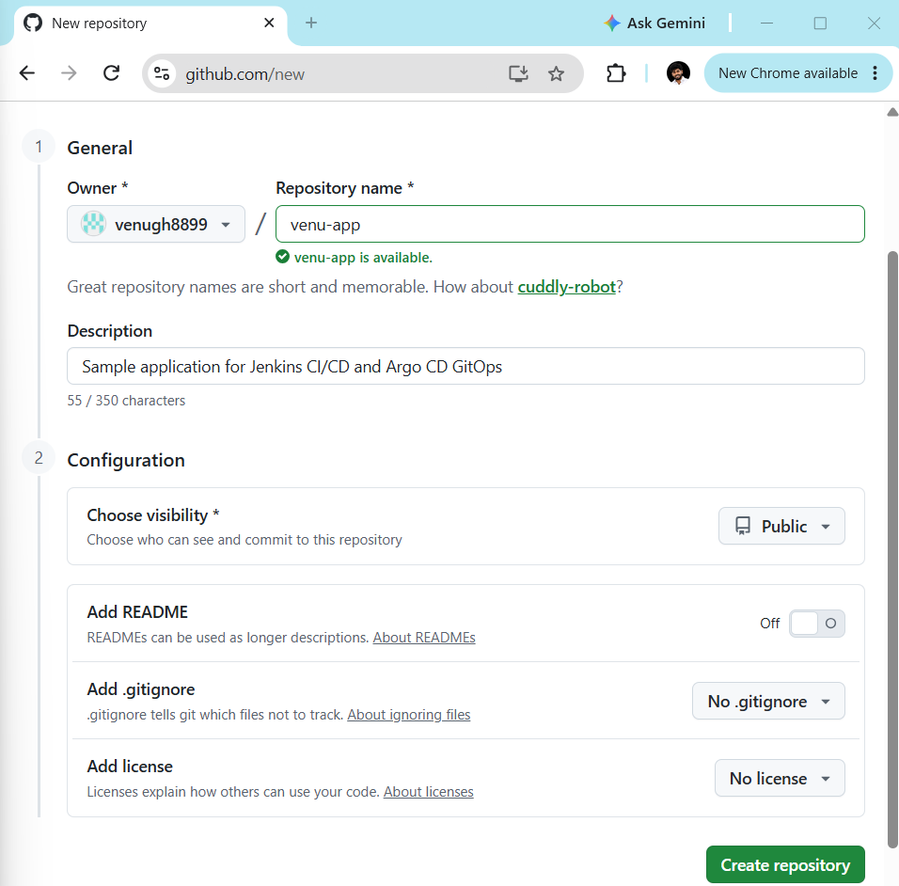
Add these two files.
index.html
<!DOCTYPE html>
<html>
<head>
<title>Venu DevOps App</title>
</head>
<body>
<h1>Hello from Venu DevOps CI/CD!</h1>
<h2>Deployed using Jenkins + Docker + Argo CD + EKS</h2>
</body>
</html>
Dockerfile
FROM nginx:latest

COPY index.html /usr/share/nginx/html/index.html

EXPOSE 80
Push both files to GitHub.
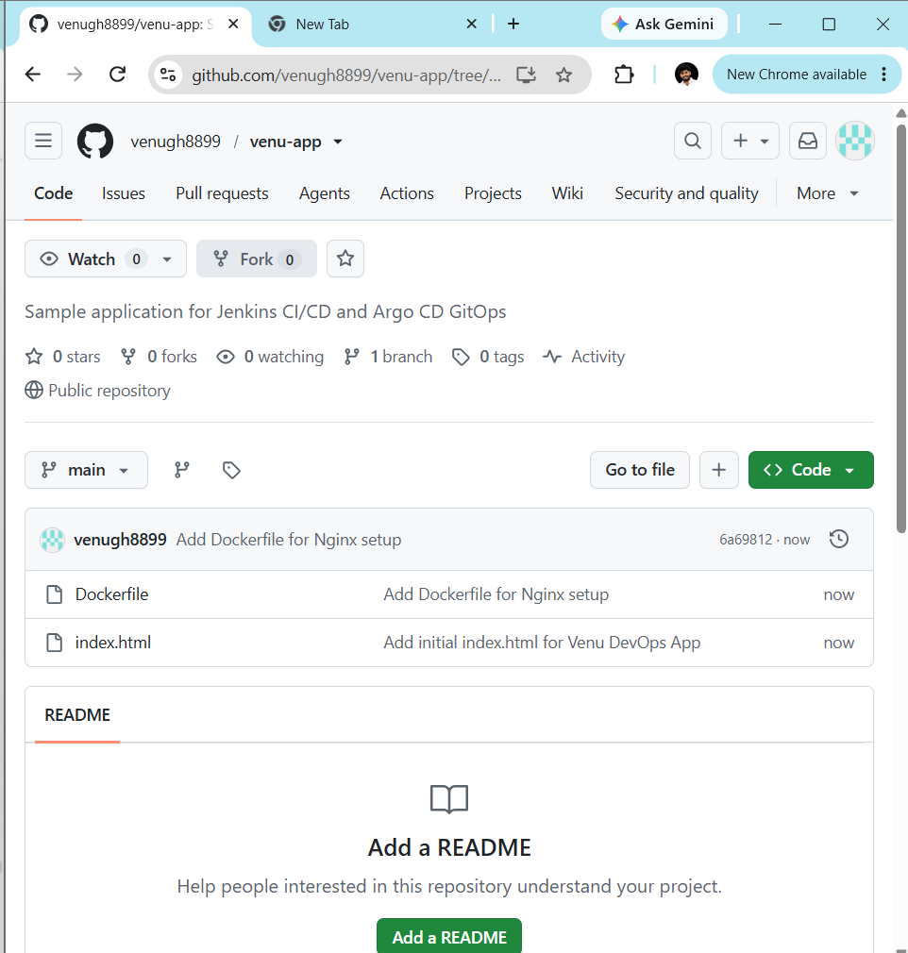

Step 2: Jenkins → GitHub connection
In Jenkins:
Manage Jenkins → Credentials → System → Global credentials
Create GitHub credential.
For example:
ID: github-creds
Username: YOUR_GITHUB_USERNAME
Password: YOUR_GITHUB_TOKEN
Use a GitHub Personal Access Token, not your GitHub password.

Step 3: Create Jenkins CI Job
Jenkins:
New Item → Pipeline
Name:
venu-app-ci
Select:
Pipeline
Click OK.
Under Pipeline → Definition:
Pipeline script
Use:
pipeline {
agent any

stages {

stage('Checkout') {
steps {
git branch: 'main',
credentialsId: 'github-creds',
url: 'https://github.com/YOUR_USERNAME/venu-app.git'
}
}

stage('Build') {
steps {
echo 'Application build started'
sh 'ls -la'
}
}

stage('Test') {
steps {
echo 'Running application tests'
}
}

stage('CI Success') {
steps {
echo 'CI pipeline completed successfully!'
}
}
}
}
Replace:
YOUR_USERNAME
with your GitHub username.
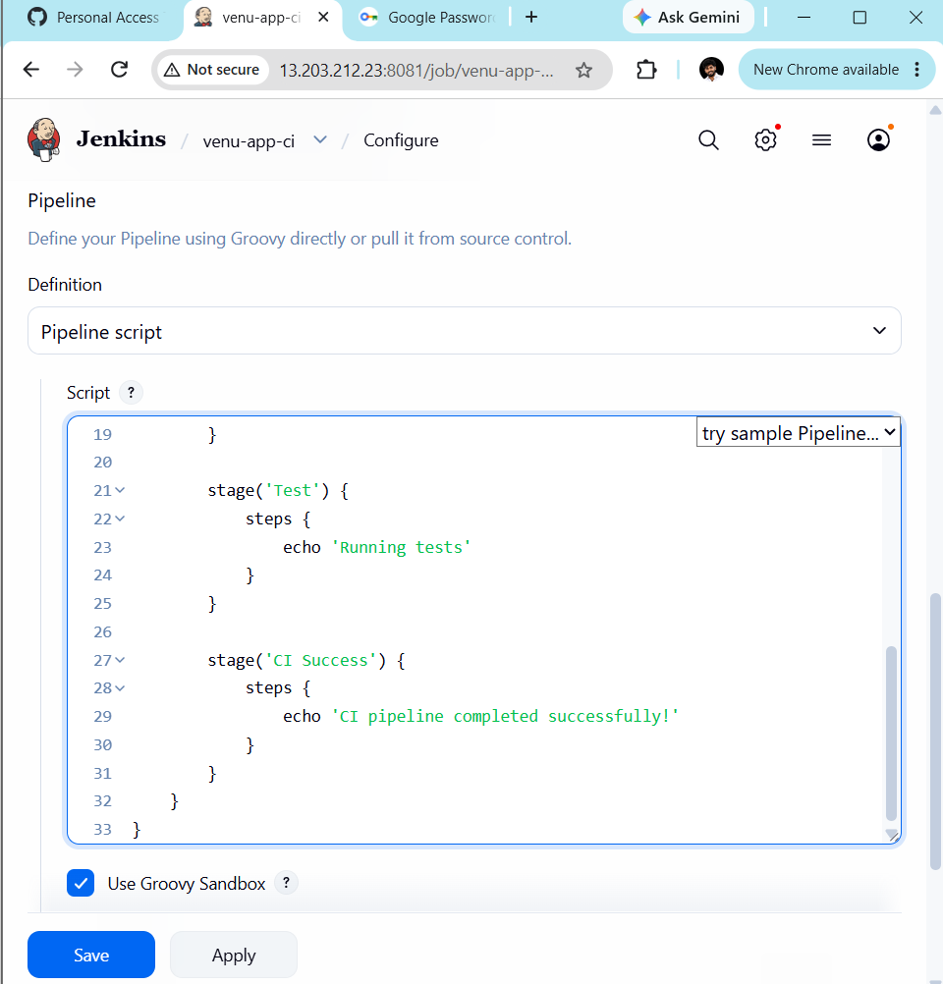
Click:
Save → Build Now
Expected:
Checkout SUCCESS
Build SUCCESS
Test SUCCESS
CI Success SUCCESS
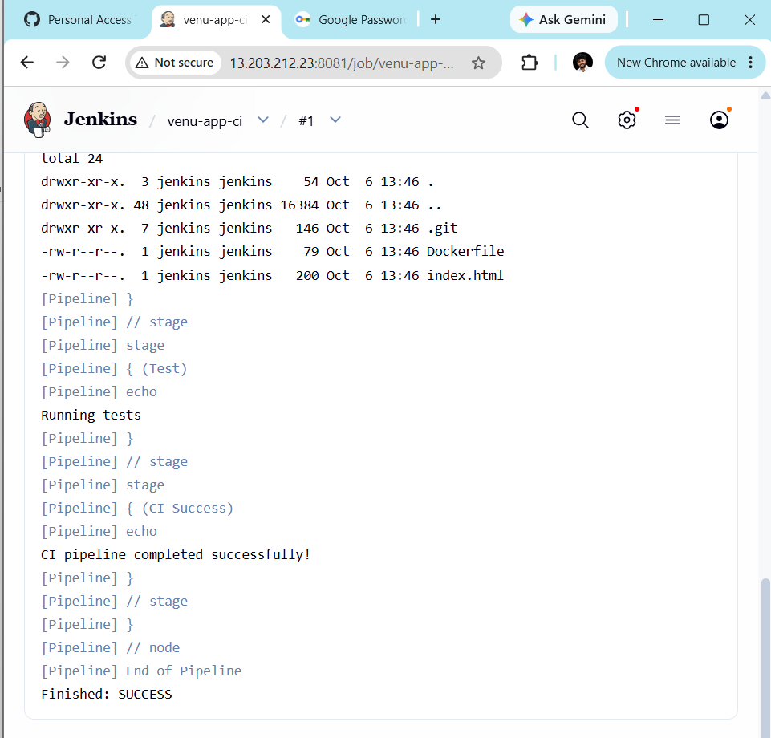
TASK 3 — Jenkins Docker Build + Push
Now we create a second Jenkins job.
This job will:
GitHub
↓
Checkout
↓
Docker Build
↓
Docker Login
↓
Docker Push
Step 1: Create Docker Hub repository
Create:
venu-app
on Docker Hub.
Your image will look like:
YOUR_DOCKER_USERNAME/venu-app:BUILD_NUMBER
Example:
venugopal/venu-app:15
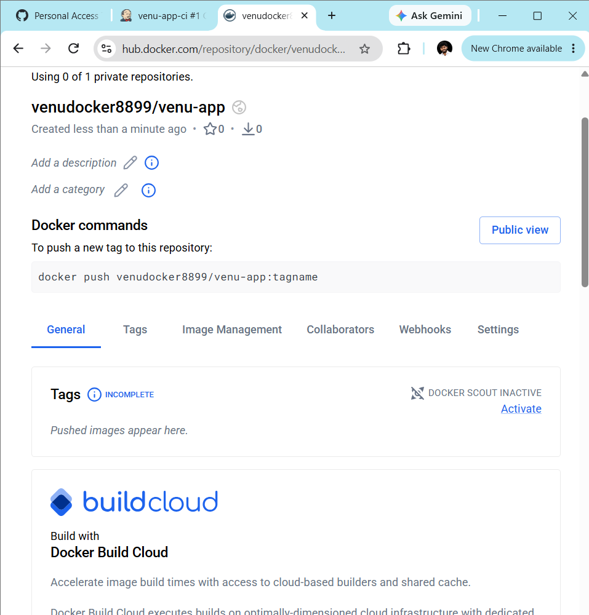

Step 2: Add Docker Hub credentials to Jenkins
Go to:
Manage Jenkins → Credentials → Global
Create:
ID: dockerhub-creds
Username: YOUR_DOCKER_USERNAME
Password: YOUR_DOCKERHUB_TOKEN
Again, use a Docker Hub access token instead of your actual password.
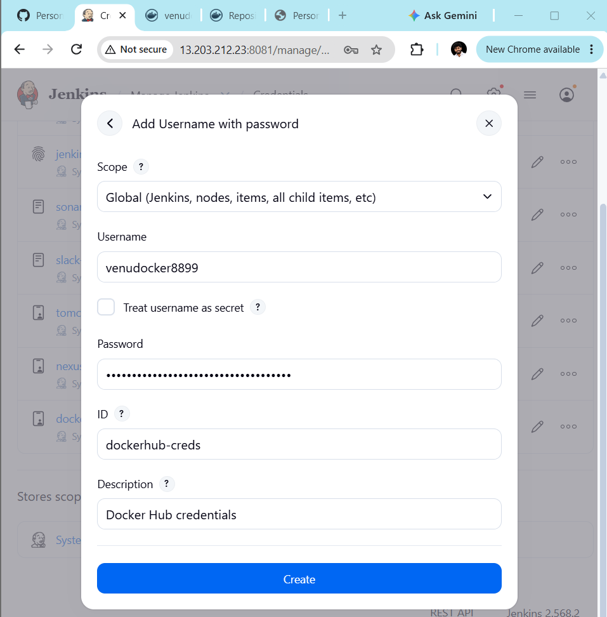

Step 3: Create Jenkins job
Create:
venu-docker-build
Type:
Pipeline
Use:
pipeline {

agent any

environment {
IMAGE_NAME = 'YOUR_DOCKER_USERNAME/venu-app'
IMAGE_TAG = "${BUILD_NUMBER}"
}

stages {

stage('Checkout') {
steps {
git branch: 'main',
credentialsId: 'github-creds',
url: 'https://github.com/YOUR_USERNAME/venu-app.git'
}
}

stage('Docker Build') {
steps {
sh '''
docker build \
-t ${IMAGE_NAME}:${IMAGE_TAG} \
-t ${IMAGE_NAME}:latest .
'''
}
}

stage('Docker Login') {
steps {
withCredentials([
usernamePassword(
credentialsId: 'dockerhub-creds',
usernameVariable: 'DOCKER_USER',
passwordVariable: 'DOCKER_PASS'
)
]) {
sh '''
echo "$DOCKER_PASS" | docker login \
-u "$DOCKER_USER" \
--password-stdin
'''
}
}
}

stage('Docker Push') {
steps {
sh '''
docker push ${IMAGE_NAME}:${IMAGE_TAG}
docker push ${IMAGE_NAME}:latest
'''
}
}

stage('Docker Image') {
steps {
echo "Docker image pushed successfully"
echo "Image: ${IMAGE_NAME}:${IMAGE_TAG}"
}
}
}
}
Replace:
YOUR_DOCKER_USERNAME
YOUR_USERNAME
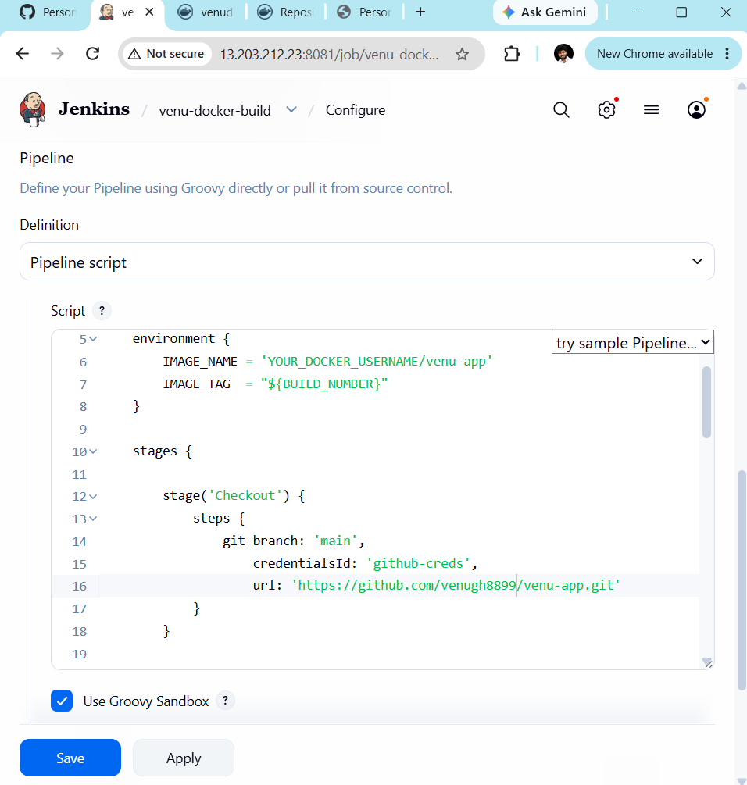
Run:
Build Now
Expected:
Docker Build SUCCESS
Docker Login SUCCESS
Docker Push SUCCESS
Then check Docker Hub.
You should see:
venu-app
├── latest
├── 1
├── 2
└── 3
depending on your Jenkins build number.
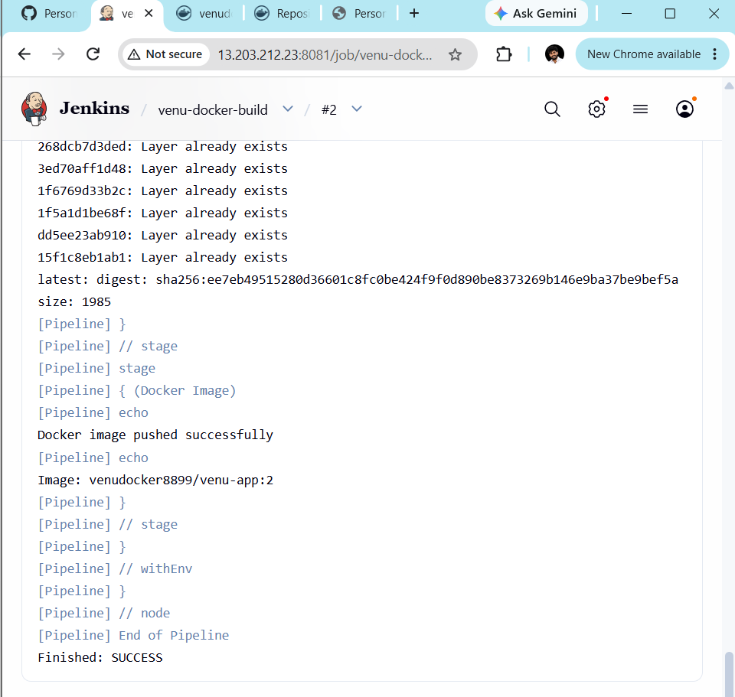

TASK 4 — Argo CD Deploy to EKS
This is the important GitOps part.
Create another GitHub repository:
venu-gitops
Repository structure:
venu-gitops
│
├── deployment.yaml
├── service.yaml
└── application.yaml
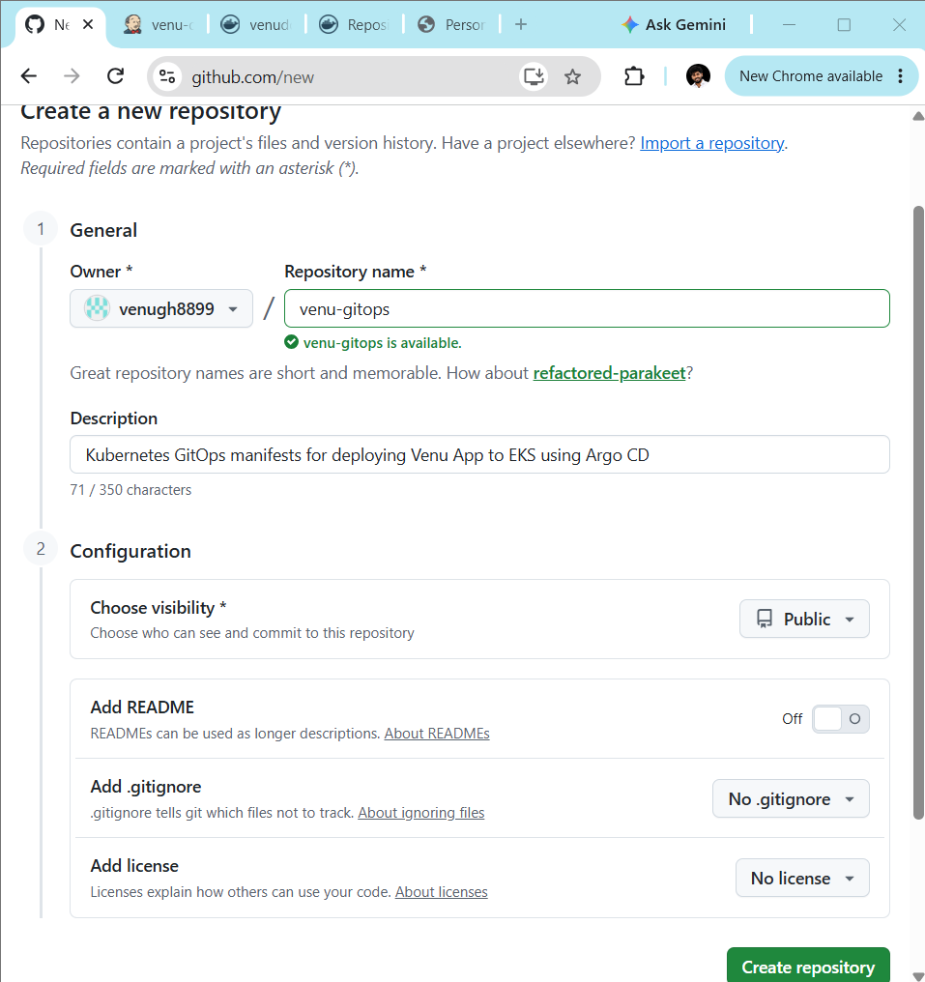

Step 1: deployment.yaml
Replace YOUR_DOCKER_USERNAME.
apiVersion: apps/v1
kind: Deployment

metadata:
name: venu-app

spec:
replicas: 2

selector:
matchLabels:
app: venu-app

template:
metadata:
labels:
app: venu-app

spec:
containers:
- name: venu-app

image: YOUR_DOCKER_USERNAME/venu-app:latest

ports:
- containerPort: 80

resources:
requests:
cpu: "50m"
memory: "64Mi"

limits:
cpu: "200m"
memory: "256Mi"
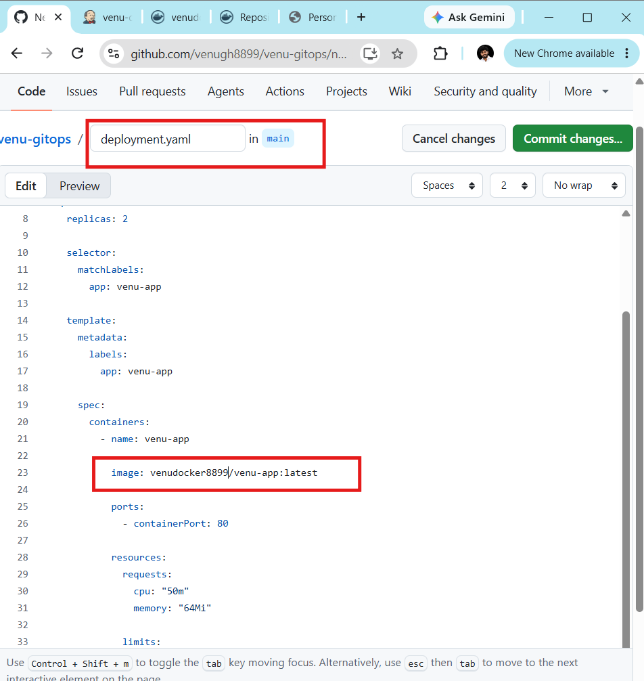

Step 2: service.yaml
apiVersion: v1
kind: Service

metadata:
name: venu-app-service

spec:
type: LoadBalancer

selector:
app: venu-app

ports:
- port: 80
targetPort: 80
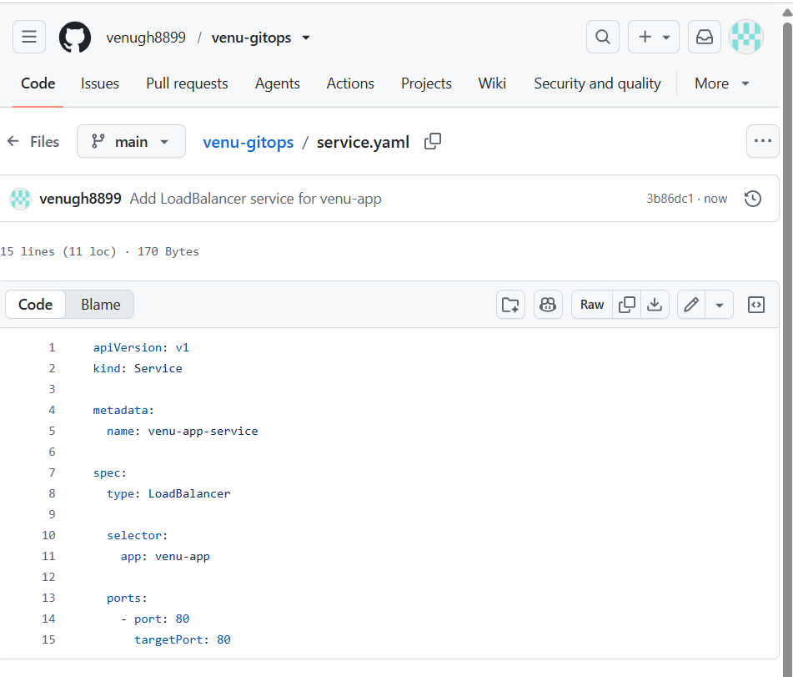

Step 3: application.yaml
apiVersion: argoproj.io/v1alpha1
kind: Application

metadata:
name: venu-app
namespace: argocd

spec:

project: default

source:
repoURL: https://github.com/YOUR_USERNAME/venu-gitops.git
targetRevision: main
path: .

destination:
server: https://kubernetes.default.svc
namespace: venu-app

syncPolicy:
automated:
prune: true
selfHeal: true

syncOptions:
- CreateNamespace=true
Replace:
YOUR_USERNAME
with your GitHub username.
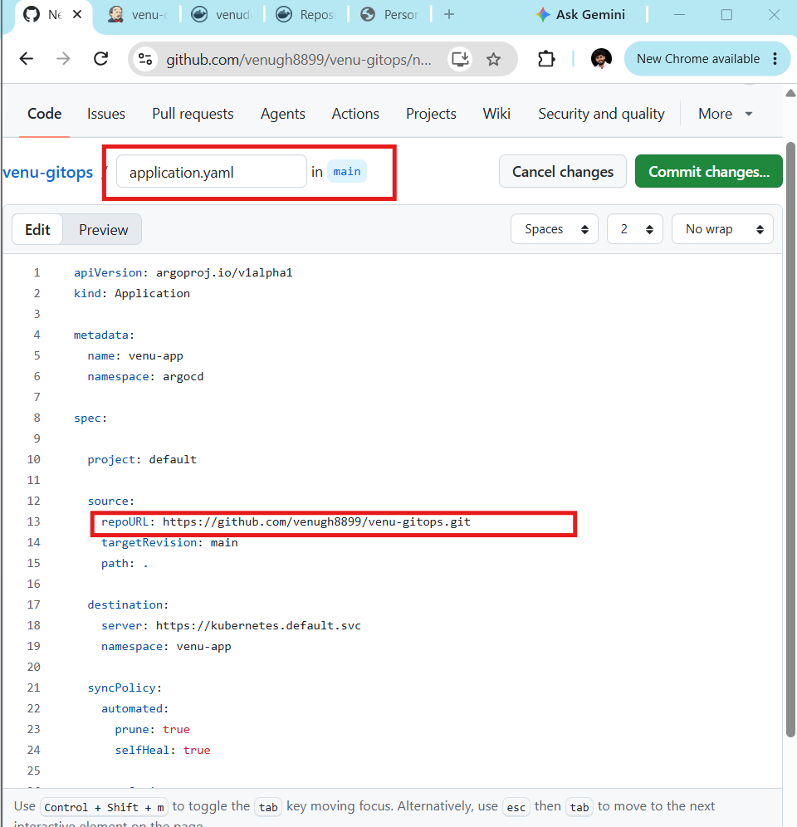
Push all three files:
venu-gitops
├── deployment.yaml
├── service.yaml
└── application.yaml
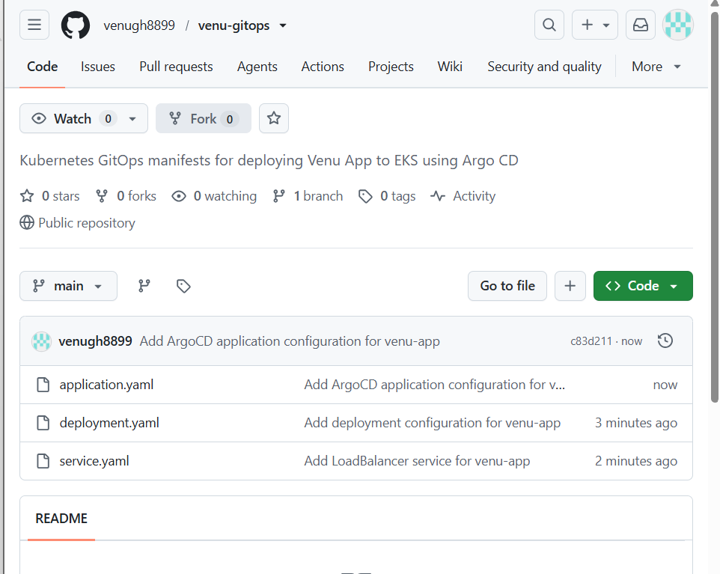

Step 4: Connect Argo CD to GitOps repo
We need to tell Argo CD:
"Watch this GitHub repo, take the Kubernetes manifests from it, and deploy them into my EKS cluster."
Since you already logged into Argo CD CLI through localhost:8443, run:
./argocd.exe app create venu-app \
--repo https://github.com/venugh8899/venu-gitops.git \
--path . \
--dest-server https://kubernetes.default.svc \
--dest-namespace venu-app \
--directory-recurse
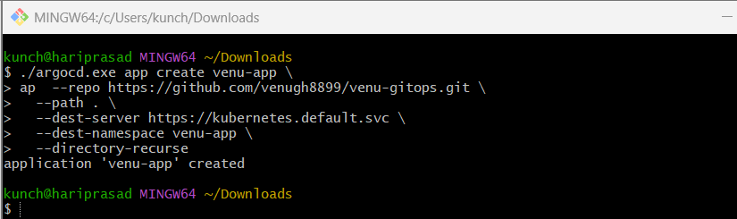
What each part means
venu-app
↓
Argo CD Application name

--repo
↓
GitHub GitOps repository

--path .
↓
Manifests are in repository root

--dest-server
↓
Current EKS cluster

--dest-namespace venu-app
↓
Deploy application into namespace venu-app
Then check
./argocd.exe app list
You should see something similar to:
NAME CLUSTER NAMESPACE STATUS
venu-app https://kubernetes.default.svc venu-app OutOfSync
OutOfSync initially is okay — it means Argo CD has detected the Git repository but hasn't synchronized it yet.
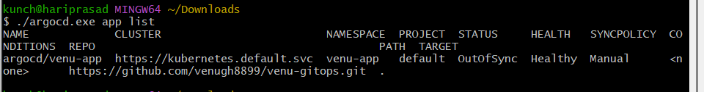
Then run:
./argocd.exe app sync venu-app
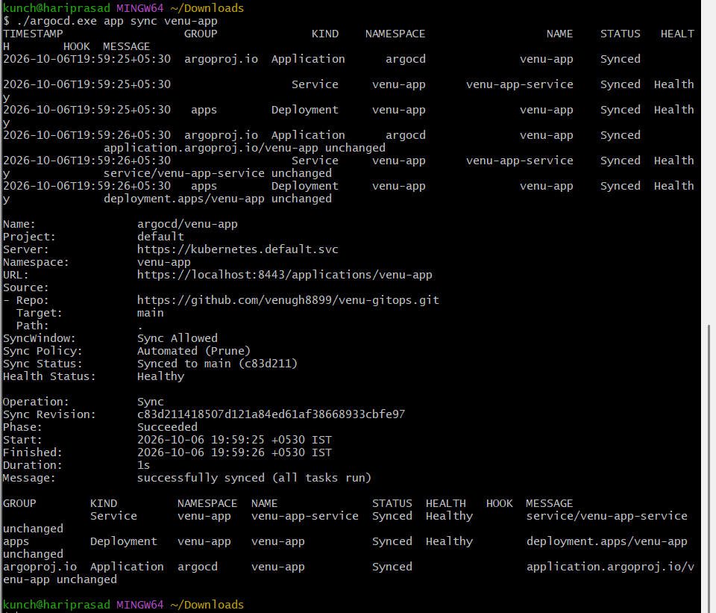
After that:
./argocd.exe app get venu-app
We want:
Sync Status: Synced
Health Status: Healthy
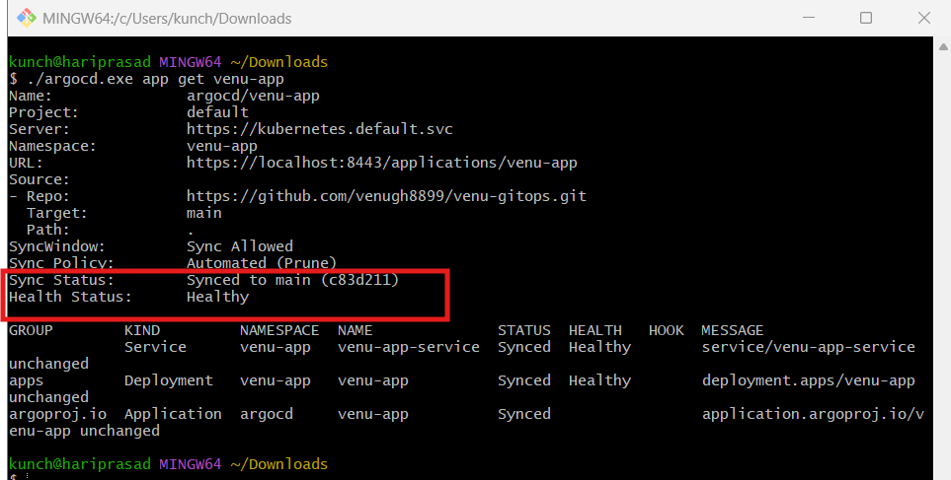

STEP 5 — Connect Jenkins to GitOps Repository
5.1 Create GitHub Personal Access Token
You need a GitHub token that Jenkins can use to push changes to venu-gitops.
In GitHub:
Profile → Settings → Developer settings → Personal access tokens → Tokens
Create a token with repository access to:
venugh8899/venu-gitops
For a classic token, give:
repo
permission.
Copy the token.
⚠️ Don't send the token here.

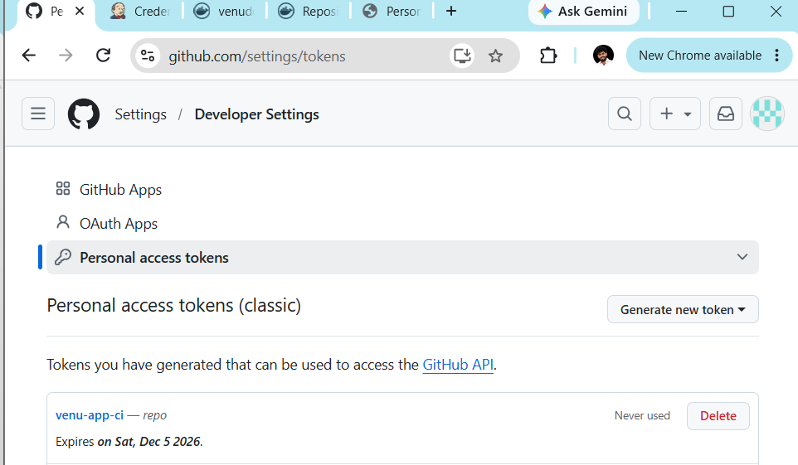

STEP 6 — Add GitHub credential to Jenkins
Go to:
Jenkins → Manage Jenkins → Credentials → System → Global credentials → Add Credentials
Choose:
Kind: Username with password
Scope: Global

Username: venugh8899
Password: <GitHub Personal Access Token>

ID: github-creds

Description: GitHub credentials
Click Create.
Important
Earlier your Jenkins log showed:
CredentialId "github-creds" could not be found
Now we're fixing exactly that.
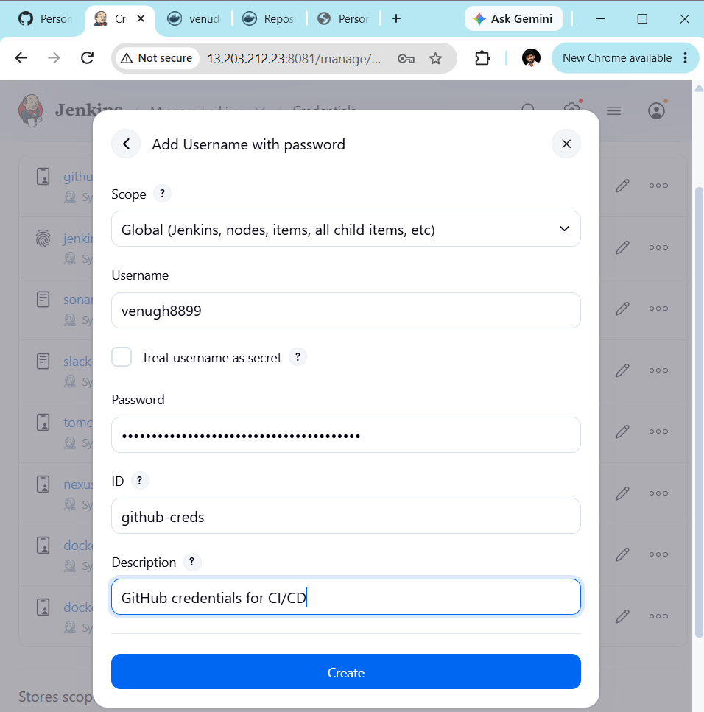

STEP 7 — Clone GitOps repository on Jenkins
We need Jenkins to download:
https://github.com/venugh8899/venu-gitops.git
and modify:
deployment.yaml
The deployment currently needs to contain:
image: venudocker8899/venu-app:latest
But instead of latest, we're going to use Jenkins build numbers.
For example:
Build #1
venudocker8899/venu-app:1

Build #2
venudocker8899/venu-app:2

Build #3
venudocker8899/venu-app:3
This is much better for GitOps because every deployment has a traceable image version.
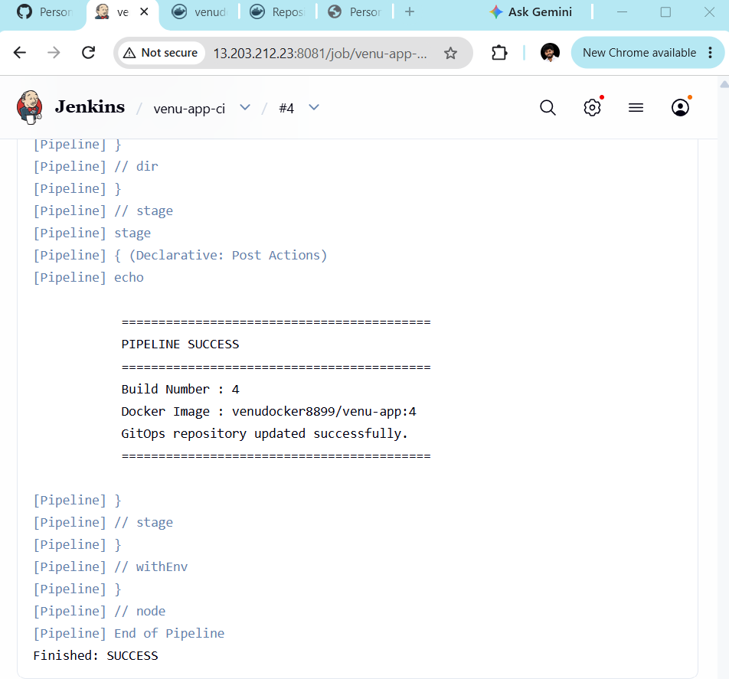

STEP 8 — Update Jenkinsfile
Your venu-app repository already has a Jenkins pipeline that successfully:
Checkout
↓
Docker Build
↓
Docker Login
↓
Docker Push
Now add:
Update GitOps
↓
Commit
↓
Push to GitHub
Use this Jenkinsfile:
pipeline {
agent any

environment {
IMAGE_NAME = "venudocker8899/venu-app"
IMAGE_TAG = "${BUILD_NUMBER}"
GITOPS_REPO = "https://github.com/venugh8899/venu-gitops.git"
}

stages {

stage('Checkout') {
steps {
git(
url: 'https://github.com/venugh8899/venu-app.git',
branch: 'main'
)
}
}

stage('Docker Build') {
steps {
sh '''
docker build \
-t ${IMAGE_NAME}:${IMAGE_TAG} \
-t ${IMAGE_NAME}:latest .
'''
}
}

stage('Docker Login') {
steps {
withCredentials([
usernamePassword(
credentialsId: 'dockerhub-creds',
usernameVariable: 'DOCKER_USER',
passwordVariable: 'DOCKER_PASS'
)
]) {
sh '''
echo "$DOCKER_PASS" | docker login \
-u "$DOCKER_USER" \
--password-stdin
'''
}
}
}

stage('Docker Push') {
steps {
sh '''
docker push ${IMAGE_NAME}:${IMAGE_TAG}
docker push ${IMAGE_NAME}:latest
'''
}
}

stage('Update GitOps') {
steps {
dir('gitops') {

git(
url: "${GITOPS_REPO}",
branch: 'main',
credentialsId: 'github-creds'
)

sh '''
sed -i "s|image: .*|image: ${IMAGE_NAME}:${IMAGE_TAG}|" deployment.yaml

git config user.name "Jenkins"
git config user.email "jenkins@localhost"

git add deployment.yaml

git commit -m "Update venu-app image to ${IMAGE_TAG}" || true

git push origin main
'''
}
}
}
}

post {
success {
echo 'CI/CD pipeline completed successfully!'
}

failure {
echo 'Pipeline failed!'
}
}
}

STEP 9 — Check deployment.yaml
Before running Jenkins, open your GitHub:
venugh8899/venu-gitops → deployment.yaml
The container image should look like:
containers:
- name: venu-app
image: venudocker8899/venu-app:1
or:
image: venudocker8899/venu-app:latest
Our Jenkins pipeline will automatically replace that line.
For example, Jenkins Build #2 changes:
image: venudocker8899/venu-app:1
to:
image: venudocker8899/venu-app:2

STEP 10 — Configure Jenkins Job
Go to your existing Jenkins job:
venu-docker-build
Click:
Configure → Pipeline
For Pipeline Definition, use:
Pipeline script
Paste the Jenkinsfile above.
Click:
Save

STEP 11 — Run Jenkins
Click:
Build Now
The pipeline should execute:
Checkout ✅
Docker Build ✅
Docker Login ✅
Docker Push ✅
Update GitOps ✅
The important final message should be:
Finished: SUCCESS

STEP 12 — Verify GitOps Repository
Go to:
venugh8899/venu-gitops
Open:
deployment.yaml
You should see something like:
image: venudocker8899/venu-app:2
And GitHub should show a Jenkins commit:
Update venu-app image to 2
🔥 This proves Jenkins successfully updated Git.
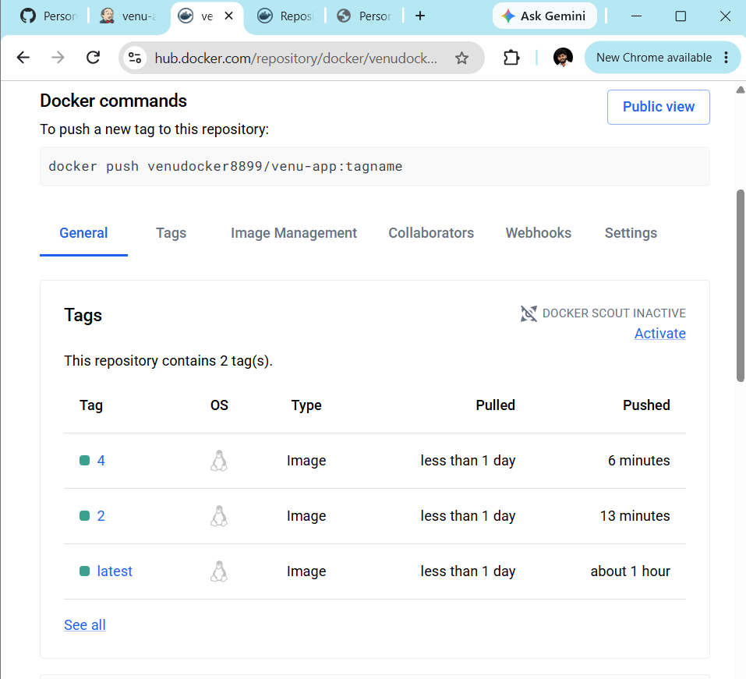

STEP 13 — Argo CD detects the Git change
Argo CD is already watching:
https://github.com/venugh8899/venu-gitops.git
So after Jenkins pushes:
deployment.yaml
↓
image: ...:2
Argo CD detects the new Git commit.
Check:
./argocd.exe app get venu-app
You may see:
Sync Status: OutOfSync
briefly.
Because our Application was configured with automated sync, Argo CD should then synchronize automatically.
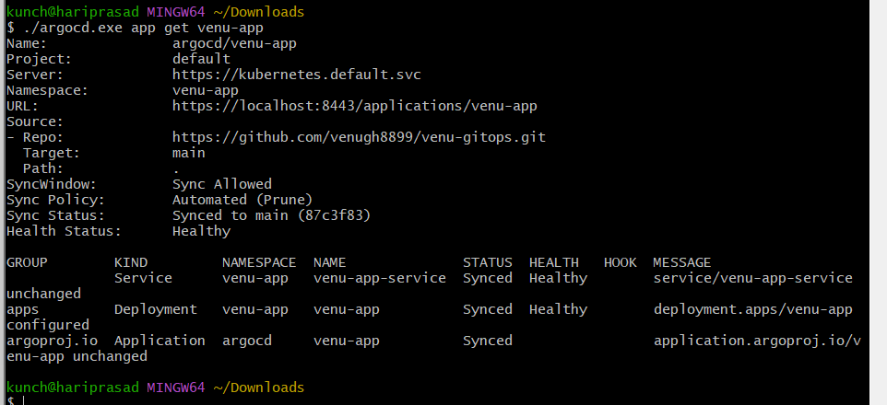

STEP 14 — Verify Kubernetes
Run:
kubectl get pods -n venu-app
Then:
kubectl get deployment -n venu-app
And check the actual image:
kubectl get deployment venu-app \
-n venu-app \
-o jsonpath="{.spec.template.spec.containers[0].image}"
Expected after Build #2:
venudocker8899/venu-app:2
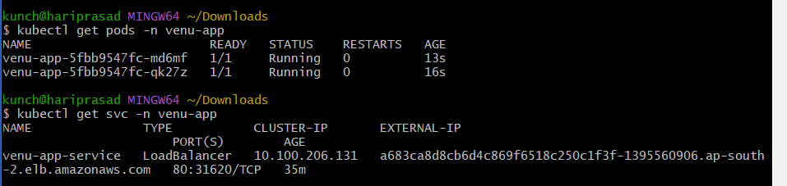

STEP 15 — Verify Argo CD
./argocd.exe app get venu-app
We want:
Sync Status: Synced
Health Status: Healthy
